ANGEL ROMERO, JULIA TORGOVITSKAYA,
(and that other guy):
VERISIMILITUDE AND VERIDICALITY
by Francis Baumli, Ph.D.

INTRODUCTION

My essay makes sense only within the context of a certain concert, and a review of that concert, which was written by long-time St. Louis Post-Dispatch music critic Sarah Bryan Miller. I here reprint that concert’s program, Miller’s review, and my response to Sarah Bryan Miller’s review. (It bears noting that the performance did not entirely follow the program.)
As I stated to a friend: “Sarah Bryan Miller threw a grenade. I responded with an artillery shell.”
My friend commented wryly, “Yes; that’s your usual way.” Indeed she is correct. As I often say to people, “There are two ways we must humbly look at every situation. There is the wrong way, and there is ... my way.”
I: THE CONCERT PROGRAM (1-24-2015)

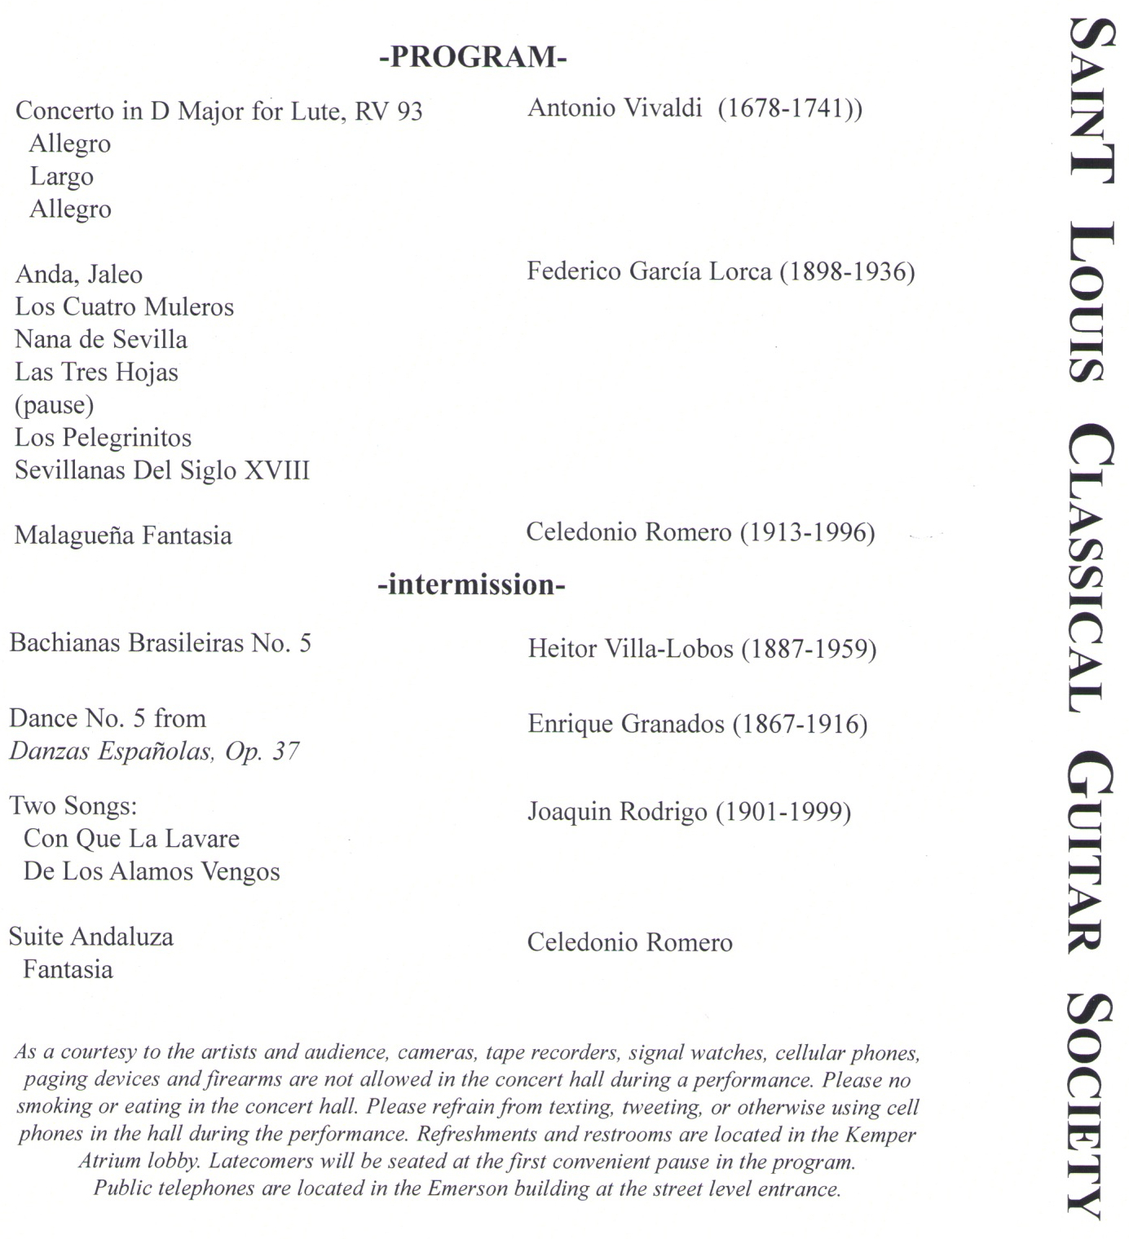
II: SARAH BRYAN MILLER’S REVIEW
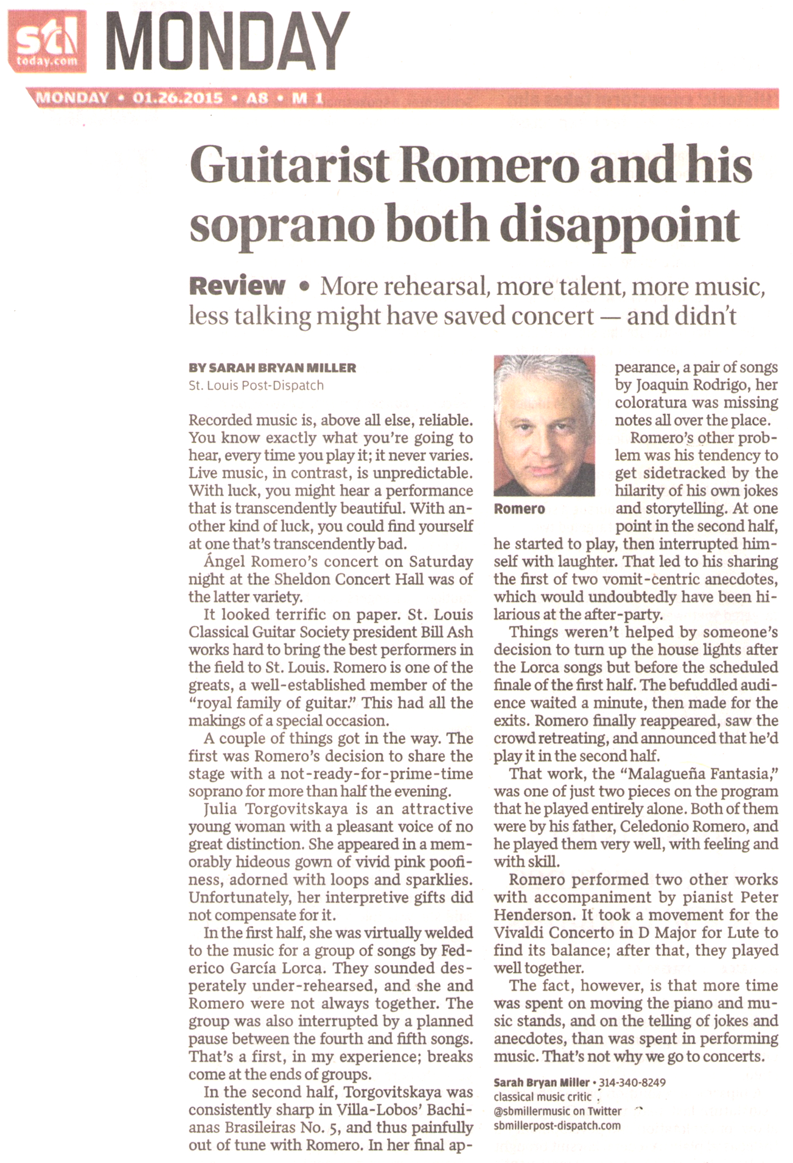
III: HOW SARAH BRYAN MILLER GOT IT WRONG

In her review, “Guitarist Romero and His Soprano Both Disappoint,” (St. Louis Post-Dispatch, 1-26-2015, p. A8, M 1) music reviewer Sarah Bryan Miller (aka SBM) seemed entirely out of her element. She levied a volley of scarcely-deserved criticism which here warrants a response.
Her view toward the soprano Julia Torgovitskaya was nothing less than snarky, taking her to task for her “hideous gown” with its “pink poofiness.” Well, Torgovitskaya is Moscow born, and I would have called her gown “Regal Russian” with a hint of Spanish gypsy. Ergo, entirely appropriate for the evening’s music. But SBM didn’t like her voice either. I admit that Torgovitskaya is not quite a peer with the best Mozart or Schubert interpreters, but with this evening’s repertoire (it is folk music, if you please!), I thought her voice perfect. If she and Angel Romero were not always quite together, to my scarcely unpracticed ear this sounded like interpretative variety that melded creative nuance, not under-rehearsed uncertainty as SBM judged it. And as for SBM’s pronouncement that Torgovitskaya was consistently sharp in the Bachianas Brasileiras No. 5 by Villa-Lobos, SBM is flat wrong. Torgovitskaya was occasionally slightly sharp (according to the perfect pitch my ears possess), and here arises an interesting musical phenomenon. Singers sometimes tend to sing sharp because of bad musicianship; other times singing slightly sharp results from enthusiasm. The latter has been noted and appreciated by music critics as eminent as Karl Haas and Jim Svejda, and by conductors as renowned as Fritz Reiner and Robert Shaw. Torgovitskaya’s rendition was actually only rarely and slightly sharp, which was clearly caused by an enthusiasm which occasioned a wonderfully unique rendering of this gorgeous piece as the Spanish folk song it is (however rarefied its flight!) instead of presenting it the way too many sopranos do it: as German lieder sung through a bull-horn.
And as for SBM’s criticism that Torgovitskaya’s “coloratura was missing notes”? I fear SBM does not know that one type of coloratura is embellishment. This was what I heard, and if SBM had been following this performance with a copy of the score, she might have been more admiring than critical.
Angel Romero of course was the main attraction, and while SBM believes his playing of the two works composed by his father was done “very well,” I must pronounce them superb. In fact, I have never heard a Malagueña played so well except by Carlos Montoya.
Overall, Angel Romero’s visit to Saint Louis is something we can be proud of. There have been too many geriatric classical guitarists on the Saint Louis music scene of late (Paco Peña, Odair Assad) and I confess I went to this concert worried that Angel Romero, now in his late 60s, would fit this mold. Quite the contrary. His energy was vigorous, his technique flawless, his creativity unflagging. As for the “vomit-centric” anecdotes SBM found offensive, I concede that there might be some prim concert-goers who would have found them less than tasteful. But given Angel’s extroverted and gregarious personality, they worked well, revealing a welcome human side to this performer whose world-class stature is beyond reproach. Angel’s more introverted and staid brother, Pepe, could not have pulled off these anecdotes; Angel used them to interfuse the music (and even more, the composers!) with warmth and personality. My only complaint with Angel’s patter was that it often was difficult to hear.
I am not suggesting the evening was without its problems. SBM is right to note that the house personnel mismanaged the lights. She did not note that the audience was unduly noisy with their seats, their uninhibited tubercular imitations, and they also were very intrusive given the clouds of heavy cigarette smoke during the intermission which wafted (nay; flowed) into the auditorium. Then there was the fact that most of the audience applauded at the end of movements, instead of waiting until the end of an entire piece. This was a distraction (as well as an embarrassment) for serious listeners.
SBM not only is wrong in what she criticizes, she also is askew in what she is quick to praise. For example, while she lamented how Romero and his soprano were not together, or clucked when the soprano supposedly was sharp, it seemed to escape her ears that the piano itself is tuned almost a quarter-note sharp. This is a practice occasionally done in large concert halls when the piano is paired with orchestra, since tuning the piano sharp gives the illusion that it is louder. But this practice is scarcely necessary for a venue as small as the Sheldon, and could only irritate an attentive listener. And lest we forget: What about that PhD at the piano? SBM noted that in the first work—the Vivaldi piece—the pianist and Romero were off during the first movement but then they smoothed out. Well; no they didn’t. Romero achieved a supreme state of beneficent resignation while that Bloomington boy just got worse. By the end his playing was utter travesty. My companion that night is an amateur pianist. She kept giving me horrified looks when the pianist fumbled. At the end, amidst the tepid applause, she voiced indignant criticism which, in my opinion, was much too kind. (This fellow was temporarily relieved of his usual servitude with the Saint Louis Symphony Orchestra for the sake of helping out with this concert. There are better pianists in Saint Louis. Couldn’t one of them have been brought in?)
It wasn’t a perfect concert. But Angel Romero was nearly so, Julia Torgovitskaya was just right for this program, the pianist was awful, many in the audience were crude. Doesn’t all this deserve a more measured, intelligent, and perceptive review for Saint Louis music lovers?

POSTSCRIPT

About a week after the concert, I learned some things about that performance which gave me further perspective. Namely, Angel had arrived in Saint Louis with both hands injured (his left thumb cut where it presses against the guitar’s neck; his right index finger cut at one of the joints). He had contacted his two brothers to see if one of them could fill in for him, but they both were already booked for that evening. So he went ahead and gave the concert. This is the reason the Concierto de Aranjuez by Rodrigo (which had a major role for the piano) was substituted in lieu of the “Dance No. 5” from Danzas Españolas, Op. 37 by Granados (as printed on the program). The idea was that this substitution would give the guitarist less responsibility. But it also meant more rehearsal—which was done the afternoon of the evening’s concert. According to more than one person I talked with, this supposedly brief rehearsal time was a valid excuse for why the professor at the piano did not play well. I do not accept this excuse. I have played with pianists who were not yet 20 years old who could have sat down at that score and read it from sight, without needing to rehearse it for themselves—much less with Angel Romero, and done better than Peter Henderson’s ataxic hands did. I get sick of hearing excuses made for the bad playing of these academics. It seems that too many of these perfesser boys are the type who get their jobs without even needing to play well. The main thing they need to know is how to look obsequious while wearing a black bow tie. (Are you witnessing a prejudice? Of course you are. But in this case it is not irrational. It is thoroughly empirical.) The point being: The fact that Peter Henderson had “only” one afternoon to rehearse with Angel Romero is no excuse for his playing so badly. He played badly because he is an execrably bad piano player. A matter which is not arguable, so there is no need to belabor this dreary topic further. Especially considering the fact that Angel Romero, too, had only one afternoon to rehearse. But his playing, despite being encumbered by two injured hands, was nothing less than world-class.

(Written: 1-29-2015.)
(It deserves being noted that a portion of this article was published in the St. Louis Post-Dispatch newspaper in their online “Comments” section on 2-23-2015.)

(Here posted: 7-19-2015.)

